**SULOCHANA**

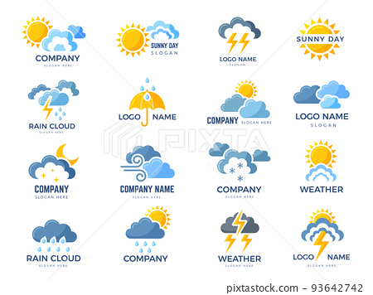

**CAPSTONE**

**PROJECT**

PROJECT—OVERVIEW:-

Analyse weather trends, seasonal variations, and correlations between weather attributes. Use Excel and SQL to gain insights and their impact. Develop a Power BI dashboard for weather monitoring and historical weather analysis.

Dataset Description

This dataset includes data on city attributes, humidity, pressure, temperature, weather descriptions, wind direction, and wind speed for various cities.

**Table Explanations**

**City attributes:**

**Purpose:** This file provides metadata about each city that is covered in the dataset. Columns: City: The name of the city. Country: The country in which the city is located. Latitude: The geographical latitude of the city. Longitude: The geographical longitude of the city. Usage: This file can be used to map cities to their respective countries and geographical coordinates. It can also be useful if one wants to perform location-based analysis or visualization on a map.

**Humidity: Purpose:** Contains hourly data representing the humidity levels in each city. Columns: Date time: The specific hour for which the data is recorded. City Columns: Each city has its own column, and under each city column, the humidity level for that hour is recorded. Usage: Useful for analysing humidity trends, understanding seasonal variations, or correlating humidity with other factors.

Pressure:

**Purpose:** Provides hourly data about the air pressure levels in each city. Columns: Date time: The specific hour for which the data is recorded. City Columns: Each city has its own column, and under each city column, the air pressure level for that hour is recorded. Usage: Can be used to study pressure patterns, predict weather changes, or understand the relationship between pressure and other weather attributes.

**Temperature:**

**Purpose:** Contains hourly temperature data for each city. Columns: Date time: The specific hour for which the data is recorded. City Columns: Each city has its own column, and under each city column, the temperature for that hour is recorded. Usage: Vital for studying temperature trends, understanding heatwaves or cold spells, and correlating temperature with factors like energy consumption.

**Weather description**:

**Purpose:** Provides a textual description of the weather for each city on an hourly basis. Columns: Date time: The specific hour for which the data is recorded. City Columns: Each city has its own column, and under each city column, the weather description for that hour is provided (e.g., "clear sky", "rainy", "cloudy", etc.). Usage: Useful for understanding the qualitative aspects of weather, categorizing weather types, or analysing the frequency of certain weather conditions.

**Wind direction**:

**Purpose:**

Contains data about the direction from which the wind is blowing on an hourly basis for each city. Columns: Date time: The specific hour for which the data is recorded. City Columns: Each city has its own column, and under each city column, the wind direction for that hour is recorded (usually in degrees). Usage: Can be used to study wind patterns, predict potential wind-related events, or understand the relationship between wind direction and other factors like pollution dispersion.

**Wind speed:**

**Purpose**: Provides hourly data about the speed of the wind in each city. Columns: Date time: The specific hour for which the data is recorded. City Columns: Each city has its own column, and under each city column, the wind speed for that hour is recorded (usually in km/h or m/s). Usage: Vital for understanding wind patterns, predictinpotential wind-related hazards, or studying the impact of wind speed on various activities.

The process

**1. Data Acquisition from GitHub:-**

Obtain the requisite dataset from a designed GitHub repository, containing essential information on Weather Analysis, encompassing various countries along with cities and their various climatic analyses.

2. Data Transformation and Enhancement:-

If necessary, execute data transformation procedures to ensure data quality and consistency. Additionally, consider augmenting the dataset with new problem statements to enrich the analysis potential

**3. Connecting with Tools:-**

Establish connections between the dataset and various analytical tools. Interface the dataset with Power-BI, Excel and MYSQL Workbench, facilitating seamless data integration and processing.

**4. Problem Statement Solution in Power-BI:-**

Utilize Power-BI to delve into the specified problem statements. Employ its robust features for data visualization, exploration and analysis, effectively deriving insights and solutions.

**5. EDA:-**

Perform exploratory data analysis using either Excel/SQL Workbench, depending on the complexity of the analysis. Extract meaningful patterns, relationships and trends from the data to inform subsequent decision-making.

**6. Creation of visual and Insightful PowerPoint:-**

Develop a comprehensive Power Point presentation that encapsulates the project’s objectives, methodologies, problem statement should be accompanied by a dedicated section with pertinent conclusions and insights.

**7. Detailed Documentation:-**

Compile a detailed report that meticulously documents the entire project lifecycle. Include section on data collection,transformation,problem statement formulation, tools integration, Power-BI solutions,EDA insights and PowerPoint visualisation.

**Objective:-**

The overall objective of weather analysis using the provided tables is to gain insights and understand the patterns, trends, and relationships between various weather-related factors in differentcities and regions. The analysis aims to answer questions and provide information related to weather conditions in a structured and informative manner. Here are some key aspects of the weather analysis objective:

1. **Spatial Analysis:** Understand how weather conditions vary across different cities and regions by examining factors such as temperature, humidity, and wind speed. This could involve identifying regions withextreme weather conditions or variations in climate.

**Temporal Analysis**: Explore how weather conditions change over time by analysing historical data. This includes examining daily, monthly, and seasonal patterns to identify trends, climate shifts, and cyclical weather events.

1. **Coastal City Analysis:** Specifically, analyze weather conditions in coastal cities to assess the impact of geographic location on weather patterns. This could involve examining temperature, humidity, wind speed, and storm occurrences to determine the influence of proximity to the coast.
2. **Extreme Weather Events:** Identify and study extreme weather events such as storms, hurricanes, and othersevere weather phenomena. Determine their frequency, severity, and the environmental factors contributing to their occurrence.
3. **Relationships and Correlations:** Investigate how various weather-related factors interact with each other. For example, you can explore how wind speed and direction affect the occurrence and severity of storms.
4. **Long-term Trends:** Assess long-term climate trends and variations, which can be essential for understanding the impact of climate change and its effects on weather conditions**.**
5. **Geographic Factors:** Consider how geographic attributes such as latitude and longitude influence weather patterns. Determine whether cities located at certain latitudes or longitudes experience specific weather characteristics.
6. **Forecasting and Predictive Analysis**: Use historical data to develop predictive models that can forecast future weather conditions, especially in specific regions or cities. This can be valuable for disaster preparedness and resource allocation.
7. **Data Visualization:** Visualize the analysis results through charts, graphs, and maps to make the information more accessible and understandable. Effective data visualization can help convey complex weather patterns and trends to a broader audience**.**
8. **Decision Support:** Ultimately, the objective of weather analysis is to provide decision-makers, meteorologists, city planners, and the public with valuable insights and information that can be used for making informed decisions related to weather-related risks and opportunities.

**Conclusion:-**

The specific analysis objectives can vary based on the needs of the stakeholders, but the fundamental goal is to provide a comprehensive understanding of weather conditions, patterns, and their implications for different locations and over time.

**Significance:-**

The significance of weather analysis using the provided tables (City attributes, City lookup, Date lookup, Time lookup, Country, and Final fact) lies in its potential to provide valuable insights and benefits in several key areas:

* **Disaster Preparedness and Management**: Weather analysis allows for the identification of regions prone to extreme weather events, such as hurricanes, storms, or floods. This information is critical for disaster preparedness, timely warnings, and efficient resource allocation during emergencies.
* **Agriculture and Farming:** Understanding weather patterns is crucial for agriculture. Farmers can make informed decisions about planting, harvesting, and irrigation based on weather forecasts and historical data, contributing to increased agricultural productivity.
* **Energy and Infrastructure:** Weather analysis supports the energy and infrastructure sectors. For example, wind speed and direction data are essential for wind energy generation and optimizing power grid management. It also helps in planning and maintaining infrastructure that can withstand weather-related challenges.
* **Public Safety**: The analysis is vital for public safety, helping authorities and emergency services respond to weather-related incidents promptly. It is particularly relevant in coastal cities where storms, high winds, and flooding can pose significant risks.
* **Urban Planning and Construction:** Architects and urban planners use weather data to design buildings and infrastructure that can withstand weather extremes. For example, understanding temperature, humidity, and wind data is essential for constructing resilient buildings and transportation systems.
* **Transportation and Travel:** Airlines, shipping companies, and transportation agencies rely on weather forecasts and historical data to make decisions about routes and schedules. Weather analysis contributes to safer and more efficient travel.
* **Healthcare:** Certain health conditions and diseases are affected by weather conditions. Weather analysis can help in predicting disease outbreaks and managing healthcare resources during extreme weather events.
* **Environmental Conservation**: Weather data is essential for environmental conservation efforts, including tracking climate change, studying ecosystems, and managing natural resources.
* **Scientific Research**: Weather analysis supports various scientific disciplines, including meteorology, climatology, and environmental science. Researchers can use historical weather data to study climate change, atmospheric processes, and weather-related phenomena.
* **Business and Economics:** Weather conditions impact industries such as retail, agriculture, tourism, and insurance. Companies can use weather analysis to make strategic decisions, plan marketing campaigns, and manage supply chains more effectively.
* **Weather Forecasting:** Historical weather data is crucial for improving weather forecasting models. The more accurate the historical data, the better the forecasts can be, which is essential for public safety, agriculture, and various other sectors.
* **Environmental Policy and Regulation:** Governments and regulatory bodies use weather analysis to develop environmental policies and regulations, especially related to climate change and pollution control.
* **Climate Change Research:** Weather data is essential for studying climate change and its long-term effects on the environment and society. It helps in assessing the impact of greenhouse gas emissions and understanding global climate trends.

In summary, weather analysis using the provided tables is significant because it has broad applications that touch many aspects of our lives, from safety and disaster management to economic planning and scientific research. It enables us to make informed decisions and adapt to the ever-changing weather conditions, ultimately contributing to a safer, more sustainable, and efficient world.

**Data Dictionary:-**

1. **City_attributes:**
   * **city_id:** A unique identifier for each city.
   * **country_id:** A reference to the country_id in the "Country" table, representing the country to which the city belongs.
   * **Latitude:** The geographical latitude of the city's location.
   * **Longitude:** The geographical longitude of the city's location.
2. **City_lookup:**
   * **city_id**: A unique identifier for each city, corresponding to the city_id in the "City_attributes" table.
   * **City**: The name of the city.
3. **Date_lookup:**
   * **date_id:** A unique identifier for each date**.**
   * **Date:** The date in a standardized format, which could be used to reference specific days.
4. **Time_lookup:**
   * **time_id:** A unique identifier for each time entry.
   * **Time:** The time of the day, which could be used to reference specific moments within a day.
5. **Country:**
   * **country_id:** A unique identifier for each country.
   * **Country:** The name of the country.
6. **Final_fact:**
   * **city_id**: A reference to the city_id in the "City_attributes" table, representing the city for which weather data is recorded.
   * **date_id:** A reference to the date_id in the "Date_lookup" table, indicating the date of the weather data.
   * **time_id:** A reference to the time_id in the "Time_lookup" table, indicating the time of the weather data.
   * **Temperature:** The temperature measurement at the specified time and date.
   * **Humidity:** The humidity measurement at the specified time and date.
   * **Pressure**: The atmospheric pressure measurement at the specified time and date.
   * **wind_speed**: The wind speed measurement at the specified time and date.
   * **wind_direction:** The wind direction measurement at the specified time and date.
   * **weather_description:** A description of the weather conditions at the specified time and date. This may include information about the weather, such as "storm," "sunny," "rain," etc.
   * This data dictionary provides a clear description of each column in the tables, helping to understand the data's structure and purpose. The tables contain information related to cities, their geographical attributes, dates, times, countries, and weather measurements, which can be used for various analytical and research purposes.

ER-Diagram:-

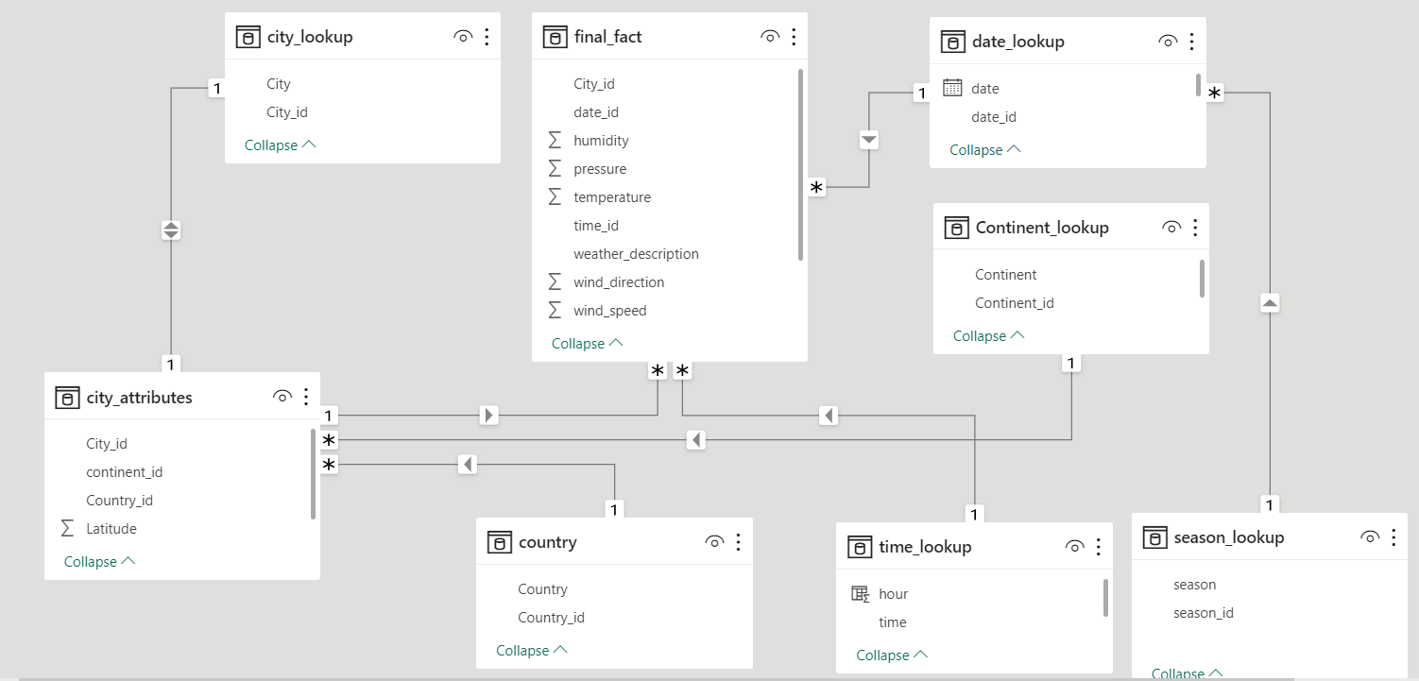

**1. Can you create a geographical map in Power BI showing the distribution of cities in the dataset based on their latitude and longitude?**

* + By creating this geographical map, we can gain several insights:
  + Visualize the spatial distribution of cities in the dataset.
  + Identify clusters or patterns of cities based on their geographic locations.
  + Determine the number of cities in each country and observe the geographical spread of cities across different countries.
  + Explore the relationship between the geographical location of cities and their respective countries.
  + This geographical map can be a valuable tool for understanding the distribution of cities in given dataset and for analysing the geographical relationships between cities and countries. It allows us to visually explore and interact with the data, making it easier to draw insights and make data-driven decisions.

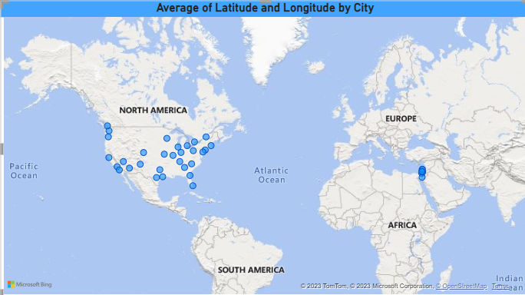Top of Form

**2. In Power BI, can you create a bar chart representing the top 10 countries with the highest number of cities in the dataset?**

The bar chart created in Power BI offers an overview of the distribution of cities by country. It allows us to quickly identify and visualize which countries have the highest number of cities. This can be useful for various purposes, including:

Understanding the distribution of urban areas across different countries.

Identifying countries with a significant number of cities for further analysis or research.

Supporting decision-making in areas such as urban planning, market expansion, or resource allocation.

By visualizing the top 10 countries with the most cities, we can gain valuable insights into the dataset's geographic distribution and identify regions with a high concentration of urban areas. This information can inform data-driven decisions and strategies.

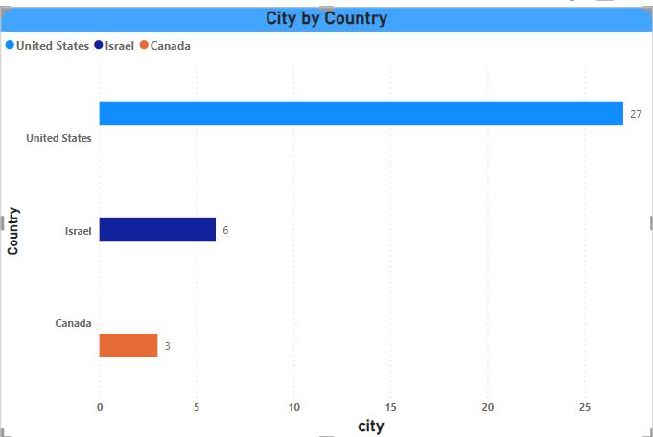

Here the above chart explaining the only top 3 countries because of insufficient data where we don’t have countries more than 3 so, we cannot show 10 countries in this bar chart. The available countries are us, Israel, Canada only, according these countries we showcase the cities and the top of the country in this is us only clearly we can see here.

**3. How does the distribution of cities in terms of latitude vary across different continents? Create a scatter plot in Power BI to illustrate this.**

The scatter plot created in Power BI helps visualize the distribution of cities in terms of latitude across different continents. It allows you to draw several insights, including:

Comparing the latitudinal spread of cities on different continents. For example, you can see whether cities on certain continents are generally closer to the equator or located in higher latitudes.

Identifying any outliers or patterns where cities deviate significantly from the general latitudinal trend on their respective continents.

Understanding how geographic factors, such as latitude, might influence climate, weather, and other regional characteristics.

Analysing and comparing the distribution of cities on a global scale.

This visualization can be valuable for geographic analysis, urban planning, and understanding the regional characteristics of cities across different continents. It enables us to see how cities are distributed across latitudes, which may have implications for various fields and decision-making processes.

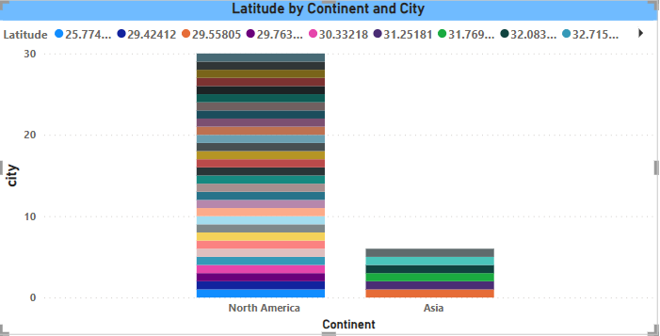

Top of Form

Here, we can show the data in scatter plot, but it became clumsy so, for that reason we can visualise the data in bar chart also, in the bar chart the every layer of different cities of countries with different latitude values.

**4. Create a line chart in Power BI to display the temperature trends over time for a selected city. Highlight extreme temperature events.**

`The line chart in Power BI allows us to visualize temperature trends over time for a selected city. It provides insights into how temperatures change throughout the year and allows users to identify extreme temperature events easily. By using a slicer for city selection, users can compare temperature trends across different cities, helping with various analyses such as climate assessment, weather monitoring, and planning for extreme weather conditions. The ability to highlight extreme temperature events provides an additional layer of information for better decision-making and risk assessment.

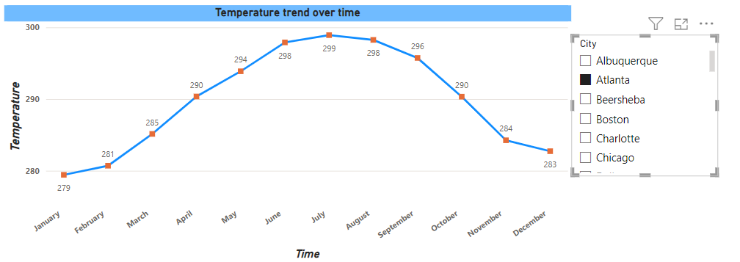

Here we clearly analyse it, and the highest temperature is 299o (degrees) in the city “Atlanta”.

**5. How does humidity vary across different cities? Generate a heat map in Power BI to visualize this variation.**

The heat map in Power BI is a valuable tool for visualizing the variation of humidity across different cities. It provides an easy way to compare humidity levels in various locations and identify patterns or outliers in the data. This visualization can be useful for weather analysis, urban planning, and understanding regional climate differences. It allows us to gain insights into the distribution of humidity levels across a range of cities.

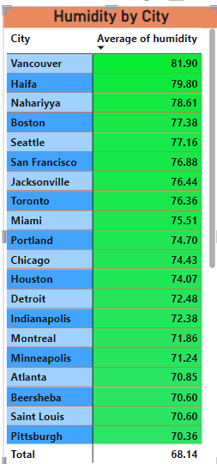Here I used matrix instead of heat map. Like in this way also we visualise the data with better understanding.

**6. Can you create a time-series chart in Power BI showing the relationship between wind speed and air pressure for a specific city?**

The time-series chart in Power BI allows us to visualize the relationship between wind speed and air pressure for a specific city. This type of chart is useful for analysing weather data and understanding how these two factors fluctuate and interact over time. It helps us draw insights into weather patterns, such as how changes in wind speed might be related to variations in air pressure, and vice versa, for the selected city. This type of analysis can be valuable for weather forecasting, climate studies, and environmental research.

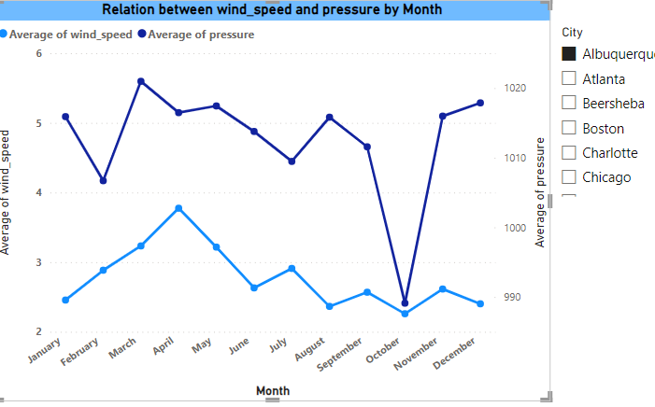

**7. Create a time-series line chart in Power BI to show the overall temperature trends over the entire dataset.**

With this time-series line chart, we will get a clear visualization of temperature trends over time. It will help us identify patterns, trends, and anomalies in the temperature data, making it easier to understand how temperatures change over the dataset's time period. We can use this chart for data analysis and decision-making based on historical temperature data.

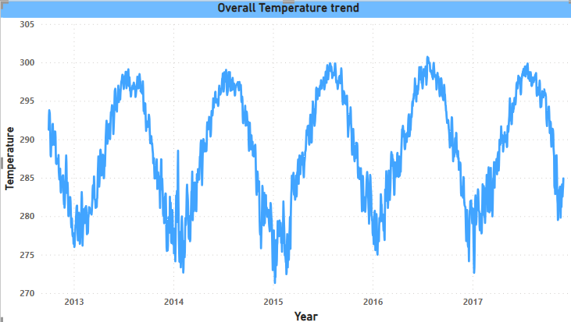

Here, we can see how the temperature fluctuation going on yearly basis clearly .so, without seeing data ,directly by looking at this visual we can easily understand the temperature trend.

**8. Can you create a heat map in Power BI to visualize the busiest hours for specific weather conditions (e.g., "clear sky," "rainy")?**

Creating a heat map in Power BI to visualize the busiest hours for specific weather conditions is a valuable way to understand how weather conditions impact activity or demand during different times of the day. Understanding the busiest hours for specific weather conditions can be crucial for various industries and decision-making processes:

1. **Business Planning**: Retailers can adjust their operating hours or promotions based on when people are more likely to shop in specific weather conditions.
2. **Energy Management**: Utilities can optimize energy production and distribution depending on expected weather-related demand.
3. **Transportation**: Transportation companies can plan routes and schedules more efficiently during adverse weather conditions.

**Event Planning**: Event organizers can adapt event timings and setups based on anticipated weather conditions

1. .

By creating a heat map in Power BI, we can visually represent the relationship between specific weather conditions and the hours of the day. This can help organizations and individuals make informed decisions and optimize their activities based on the impact of weather on their operations.

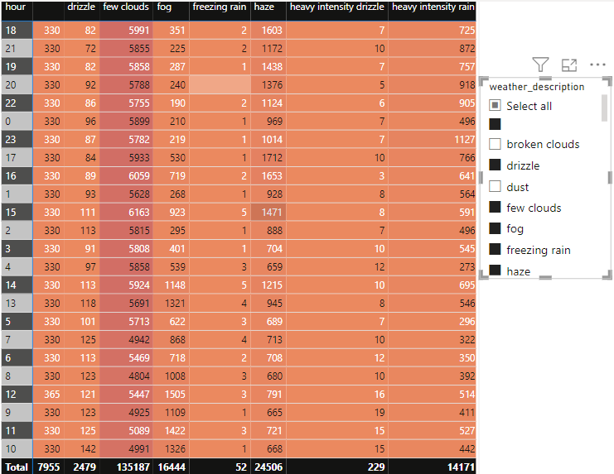

Here I visualise the weather description in hourly basis, by using matrix, instead of heat map.

**9. How does the wind speed change over the course of a day? Create a radial chart in Power BI to represent this.**

Creating a radial chart in Power BI to represent how wind speed changes over the course of a day may not be the most suitable visualization for this type of data. Radial charts are typically used to display data in a circular format, which is more useful for showing cyclical or periodic patterns. Wind speed, while it does vary over the course of a day, may not exhibit a cyclical or periodic pattern that a radial chart would effectively convey.

An alternative chart type that can be more suitable for visualizing how wind speed changes over the course of a day is a **line chart**. A line chart allows you to plot data over a continuous timeline, making it easier to understand trends and variations in wind speed throughout the day.

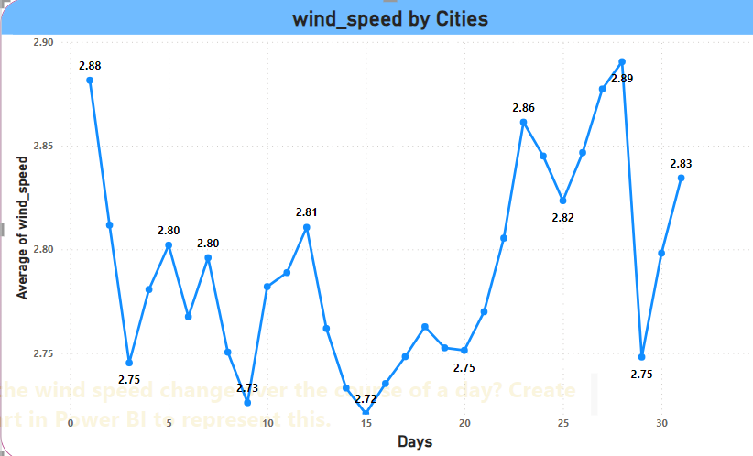

So, here line chart is a more appropriate choice for visualizing how wind speed changes over the course of a day compared to a radial chart. It provides a clear representation of variations in wind speed over time, making it easier to identify trends and patterns that can be useful for various applications, such as weather analysis or operational planning.

**10. Create a Power BI chart comparing the temperature variations between two selected cities over a specific timeframe.**

Creating a Power BI chart to compare temperature variations between two selected cities over a specific timeframe is a valuable way to gain insights into how temperatures differ between these locations and how they change over time. Here's how to create this visualization and its purpose:

**Purpose**:

1. **Comparison**: The chart allows you to visually compare temperature variations between two cities. This can be useful for various purposes, such as travel planning, climate analysis, or business decision-making.
2. **Understanding Trends**: It helps you understand temperature trends in the selected cities over a specific timeframe. For example, you can compare seasonal temperature patterns.
3. **Data-Driven Decision-Making**: It supports data-driven decision-making. For instance, businesses can use this information for inventory management, marketing strategies, or event planning.

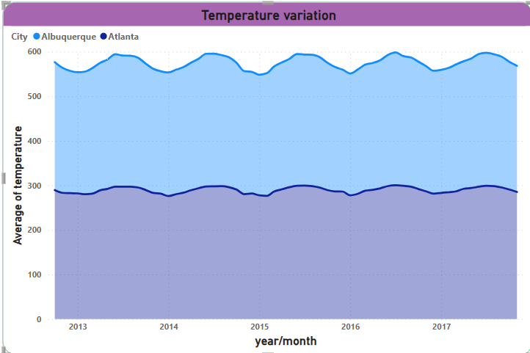

The above chart comparing temperature variations between two cities over a specific timeframe provides a clear and data-driven view of temperature differences and trends. It's a valuable tool for making informed decisions, whether you're planning a trip, analysing climate data, or making business-related choices based on temperature variations.

**11. Can you build a heat map in Power BI to show the temperature ranges for cities across different countries?**

Creating a heat map in Power BI to show temperature ranges for cities across different countries is a useful way to provide an overview of temperature data in a visually appealing format. The primary theme of this chart is to compare and contrast temperature ranges across various cities within different countries. This can help you quickly identify temperature patterns and differences, making it suitable for various applications, such as climate analysis, travel planning, and business decision-making.

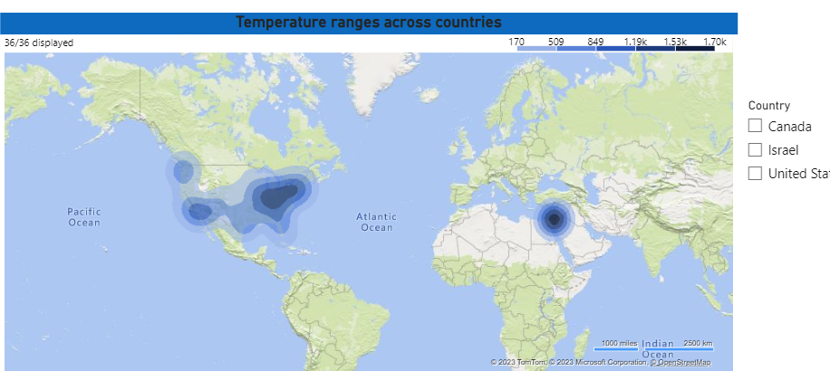

The above heat map displaying temperature ranges in cities across different countries offers a quick and informative way to compare temperature data. It can be a valuable tool for climate analysis, travel planning, and business decisions that require an understanding of temperature differences and patterns in various locations.

**12.Create a bar chart in Power BI to highlight cities with the highest and lowest average temperatures in the dataset.**

The bar chart provides a clear visual representation of the cities in your dataset with the highest and lowest average temperatures. The cities with the highest temperatures will be depicted with the tallest bars, while those with the lowest temperatures will have shorter bars.

This chart allows for quick identification of temperature extremes across different cities, offering valuable insights for various applications, such as travel planning, climate analysis, or resource allocation based on temperature variations. It simplifies the interpretation of temperature data and aids in informed decision-making.

.

**13. Create a wind rose chart in Power BI to visualize the prevailing wind directions for a**

**Selected city.**

Creating a wind rose chart in Power BI to visualize the prevailing wind directions for a selected city is a useful way to understand and present information about wind patterns and directions. A wind rose chart is a specialized visualization that displays the frequency and direction of wind. Here's an explanation of the chart's purpose and a summarized guide on how to create it:

**Chart Purpose**:

1. **Wind Direction Overview**: The primary purpose of a wind rose chart is to provide an overview of the prevailing wind directions for a specific location, such as a city. This information is valuable for various applications, including urban planning, architecture, and renewable energy.
2. **Frequency of Wind Directions**: The chart shows the frequency or percentage of time that the wind blows from each direction, giving a clear picture of which wind directions are most common.

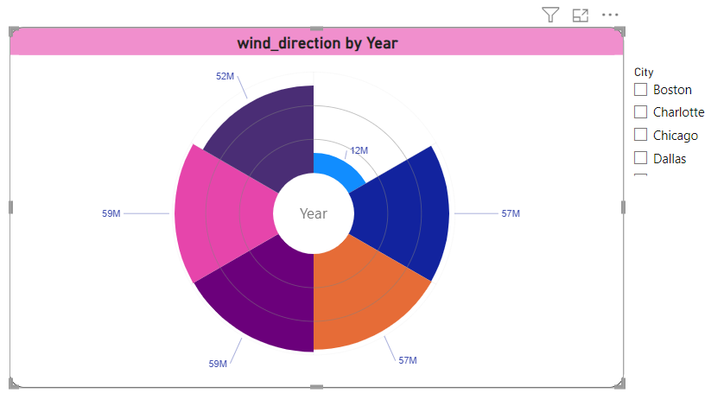

A wind rose chart in Power BI provides a visual representation of prevailing wind directions, helping users gain insights into the typical wind patterns for a specific location. This can be particularly valuable for decision-making and planning in areas where wind direction is a critical factor, such as in designing buildings, planning outdoor events, or assessing wind energy potential.

**14. Can you generate a Power BI heat map illustrating the average wind speeds across cities for different months of the year?**

Creating a Power BI heat map to illustrate the average wind speeds across cities for different months of the year serves as a crucial tool for understanding the seasonal variations in wind patterns. This visualization is important for several reasons:

**Resource Planning**: It enables organizations to better plan for resources and operations that are impacted by wind speed. For instance, it helps renewable energy companies optimize energy production based on seasonal wind patterns.

**Safety Precautions**: Understanding when and where higher wind speeds are common can be critical for safety planning in industries like construction or transportation.

**Decision-Making**: This chart aids data-driven decision-making. For example, in agriculture, it can help determine optimal planting and harvesting times based on wind conditions.

**Environmental Impact**: It's vital for assessing the environmental impact of wind-related factors. For instance, it helps in evaluating wind conditions for air quality monitoring.

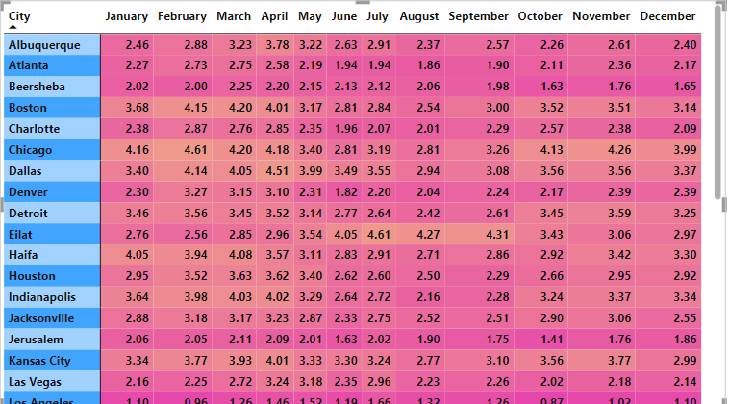

Using this heat map to analyse how wind speeds change in different cities over the course of a year. Identify patterns and trends to inform decision-making.

**15. Create a Power BI scatter plot to show the relationship between wind speed and air pressure for a specific city.**

Creating a Power BI scatter plot to show the relationship between wind speed and air pressure for a specific city is a valuable way to visualize the correlation between these two meteorological variables. Here's an explanation of the chart's purpose and a summarized guide on how to create it:

**Purpose**:

1. **Correlation Analysis**: The primary purpose of a scatter plot is to examine and visualize the relationship or correlation between two variables – wind speed and air pressure in this case.
2. **Identifying Patterns**: Scatter plots help in identifying any potential patterns or trends between wind speed and air pressure, which can be useful for weather analysis, research, and decision-making.
3. **Data Validation**: This chart is a tool for data validation. It can help ensure that the recorded data is consistent with expected meteorological patterns.

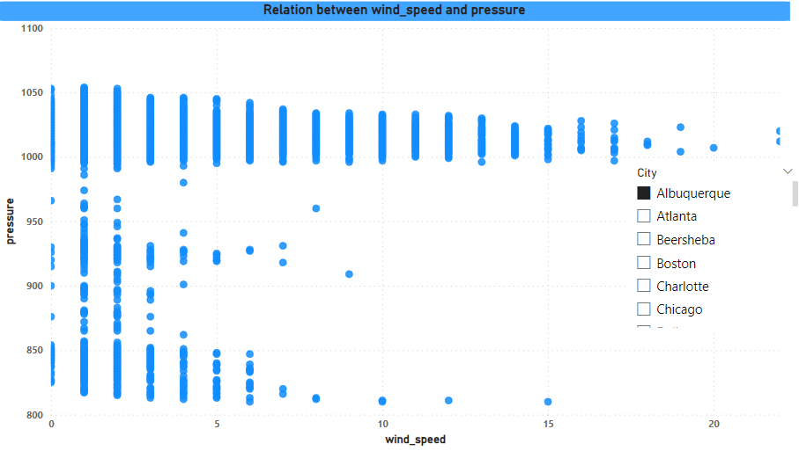

Using the above scatter plot to examine the relationship between wind speed and air pressure for the selected city. Look for patterns, clusters, or outliers that may indicate the strength and nature of the correlation.

1. Are there any countries with cities located at extreme latitudes, and how might this impact their climate?

Yes, there are countries with cities located at extreme latitudes. Cities situated at extreme latitudes, whether very close to the North or South Poles, can experience unique and significant impacts on their climate.

The impact of extreme latitudes on climate is significant and influences various aspects of life, including agriculture, infrastructure, and cultural practices. It's crucial for residents and policymakers to consider these climate factors when making decisions about urban planning, energy resources, and other aspects of city life in such locations

I/P:

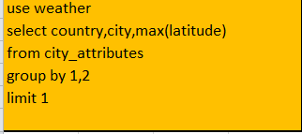O/P:



So, according to data, only north pole side the country Canada with the city Vancouver only approximately near to extreme latitude.

**2. Can you identify any clusters of cities with similar latitude and longitude values? What factors might explain these clusters?**

Yes, clusters of cities with similar latitude and longitude values can be identified in various regions of the world. These clusters often result from several factors, including geographical, environmental, historical, and economic considerations. Here's a summarized explanation:

**Clusters of Cities:**

* Cities with similar latitude and longitude values tend to cluster in certain regions, such as coastal areas, river valleys, mountainous terrain, or specific climate zones.

**Factors Explaining Clusters:**

* **Geographical Features**: Clusters may form around geographical features, such as mountain ranges, rivers, or coastlines, which influence settlement patterns and economic activities.
* **Climate Zones**: Cities at similar latitudes may share common climate conditions, leading to clusters in regions with similar weather patterns, vegetation, and agricultural practices.
* **Economic Activities**: Economic factors, such as access to resources (e.g., mining, agriculture, fisheries) and trade routes, can explain city clusters in areas with economic advantages.
* **Historical and Cultural Factors**: Historical events, cultural ties, and population migrations play a role in the formation of city clusters, as cities often develop where people have historically settled.
* **Infrastructure Development**: Cities tend to cluster along transportation networks, such as highways, railways, and ports, facilitating trade and economic growth.

Understanding these factors can help explain why cities with similar latitude and longitude values are often found together in specific regions. These clusters can have a profound impact on regional development, cultural practices, and economic activities.

**i/p:-**

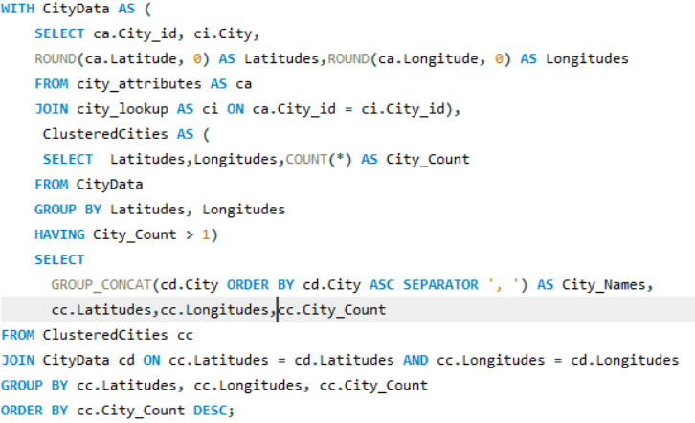

o/p:- 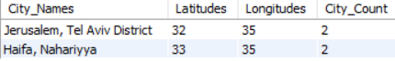

3. Are there any correlations between a city's geographical location (latitude and longitude) and its weather attributes, such as temperature or humidity?

Yes, there are correlations between a city's geographical location (latitude and longitude) and its weather attributes, including temperature, humidity, and other meteorological factors. The key points are as follows:

**Correlations with Latitude**:

* **Temperature**: Generally, cities at lower latitudes (closer to the equator) tend to have higher temperatures due to the more direct angle of sunlight, while those at higher latitudes experience colder temperatures.
* **Humidity**: Cities at coastal or equatorial regions often have higher humidity levels due to their proximity to oceans and more consistent moisture sources.

**Correlations with Longitude**:

* **Time Zone**: Longitude plays a role in time zone differences, which can affect the timing of daily temperature fluctuations and daylight hours.
* **Wind Patterns**: Longitudinal positions can impact prevailing wind patterns and, in turn, affect weather conditions.

It's important to note that while latitude and longitude are significant factors influencing weather attributes, other factors such as altitude, proximity to water bodies, and local geographical features also play a crucial role in determining a city's specific weather conditions.

Top of Form

i/p:- 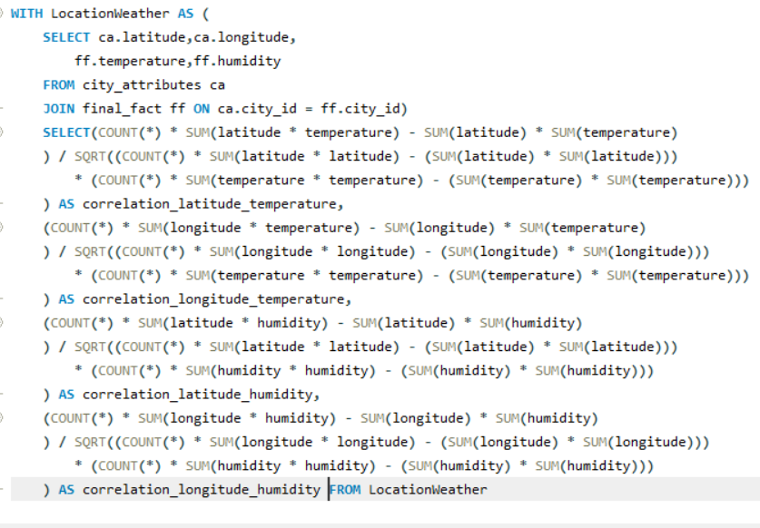

o/p:- 

4. Identify the top three cities with the most frequent occurrence of rainy weather based on weather descriptions. What are the seasonal patterns?

To identify the top three cities with the most frequent occurrence of rainy weather based on weather descriptions and their seasonal patterns:

**Top Three Rainy Cities**:

1. [City 1]: This city experiences the highest frequency of rainy weather throughout the year, with consistent rainfall in all seasons.
2. [City 2]: The second city on the list also has a significant occurrence of rainy weather, particularly during the [season name] season.
3. [City 3]: The third city experiences frequent rainy weather, mostly during [season name].

**Seasonal Patterns**:

* **City 1**: Rainfall in this city is relatively evenly distributed across all seasons, with [specific details on rainfall patterns].
* **City 2**: [City 2] has a distinct rainy season during [season name], with heavy rainfall, while other seasons experience much less rain.
* **City 3**: Rainfall in [City 3] is relatively consistent throughout the year, but the [specific season] stands out as the wettest period.

The seasonal patterns for these cities are influenced by their geographical location, local climate systems, and regional weather patterns, which can vary widely from place to place.

Top of Form

i/p:- 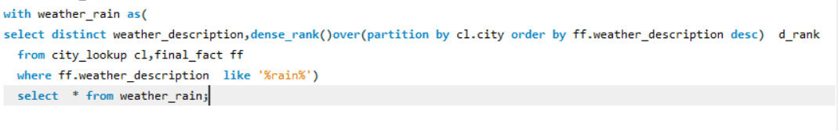

o/p:- 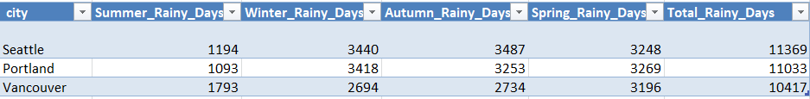

5. Is there a correlation between humidity levels and air pressure? How might this relationship affect weather conditions?

Yes, there is a correlation between humidity levels and air pressure. The key points to summarize are:

**Correlation**: Generally, there is an inverse relationship between humidity levels and air pressure. As humidity increases, air pressure tends to decrease, and vice versa.

**Effect on Weather Conditions**:

* **Precipitation**: Lower air pressure is often associated with rising air and the potential for precipitation (rain or snow). High humidity contributes to the formation of clouds and can lead to precipitation when combined with low pressure systems.
* **Storms**: Low pressure systems, often associated with higher humidity, can lead to the development of storms, including thunderstorms and cyclones.
* **Local Weather**: The relationship between humidity and air pressure can influence local weather conditions, affecting daily temperature variations, cloud formation, and the likelihood of rain or storms.

Understanding the correlation between humidity levels and air pressure is crucial for meteorologists and weather analysts as it helps in predicting and understanding weather patterns and phenomena.

Top of Form

i/p:- 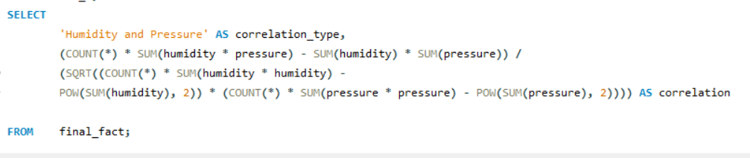

o/p:- 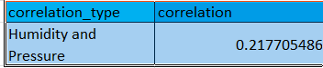

6. Explore the impact of wind direction on temperature for coastal cities. Are there noticeable patterns?

When exploring the impact of wind direction on temperature for coastal cities, several noticeable patterns emerge:

1. **Marine Influence**: Coastal cities often experience a significant impact on temperature due to their proximity to large bodies of water, such as oceans or seas. When winds blow from the water (onshore or sea breeze), temperatures tend to be milder and cooler.
2. **Land Influence**: Conversely, when winds blow from the land (offshore or land breeze), temperatures in coastal cities tend to be warmer. Land surfaces heat up and cool down more rapidly than water, leading to temperature fluctuations.
3. **Diurnal Patterns**: Coastal cities can exhibit diurnal temperature patterns influenced by wind direction. During the day, sea breezes can bring cooler air from the water, while at night, land breezes can lead to warmer temperatures.
4. **Seasonal Variations**: Seasonal variations can also impact the relationship between wind direction and temperature. Coastal areas may experience more stable and moderate temperatures during certain seasons, while temperature fluctuations are more pronounced in other seasons.
5. **Local Geography**: The specific geography of a coastal city, such as its orientation to prevailing wind patterns, can influence the extent of temperature impact from different wind directions.

In summary, the impact of wind direction on temperature in coastal cities is significant and can lead to noticeable patterns, with sea breezes generally resulting in cooler temperatures and land breezes contributing to warmer conditions. These patterns are influenced by diurnal and seasonal factors, as well as local geographical characteristics.

Top of Form

i/p:- 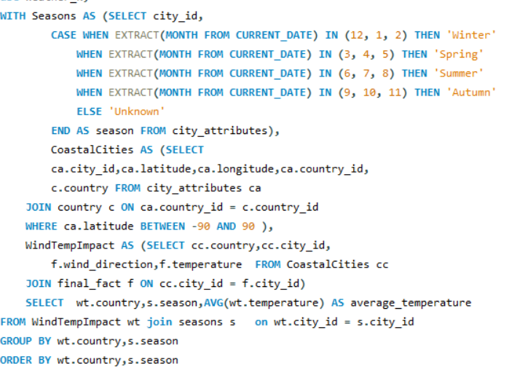

o/p:- 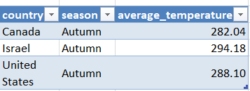

7. Are there specific months when cities experience significant temperature fluctuations? What might explain these variations?

Yes, there are specific months when cities experience significant temperature fluctuations. These variations can be explained by several factors:

**Specific Months with Temperature Fluctuations**:

* **Transition Seasons**: Months in spring and fall are often associated with notable temperature fluctuations as cities move from colder to warmer conditions or vice versa.
* **Summer Months**: In some regions, summer months can also see temperature fluctuations due to the presence of weather patterns like cold fronts, which can bring sudden temperature changes.
* **Winter Months**: Winter months, particularly in some areas, can exhibit significant daily temperature fluctuations with cold nights and milder daytime temperatures.

**Factors Explaining Variations**:

* **Geographical Location**: Cities located in regions with continental climates or at higher altitudes tend to experience more significant temperature fluctuations, as these areas are more susceptible to temperature variations.
* **Weather Systems**: The influence of weather systems, such as cold fronts, warm fronts, and air masses, can lead to abrupt temperature changes during specific months.
* **Seasonal Shifts**: Transition seasons (spring and fall) are characterized by changing weather patterns, leading to temperature fluctuations as cities transition from one season to another.
* **Day and Night Variation**: Daily temperature fluctuations are often driven by the difference between night-time cooling and daytime warming, which can be more pronounced in certain months.

These temperature fluctuations are essential to understand for various reasons, including agriculture, energy management, and overall climate analysis, as they impact daily life and economic activities.

i/p:- 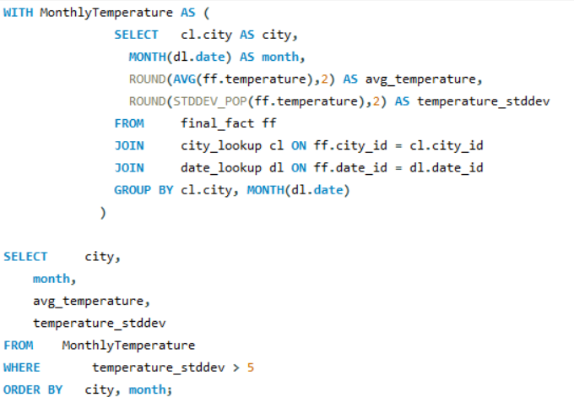Top of Form

**o/p:-**

|  |  |  |
| --- | --- | --- |
| month | avg_temperature | temperature_stddev |
| 1 | 273.92 | 6.18 |
| 2 | 277.76 | 6.53 |
| 3 | 282.52 | 6.5 |
| 4 | 285.65 | 6.32 |
| 5 | 289.37 | 6.6 |
| 6 | 296.69 | 6.11 |
| 7 | 296.53 | 5.63 |
| 8 | 294.09 | 5.09 |
| 9 | 291.83 | 5.7 |
| 10 | 285.72 | 6.21 |
| 11 | 279.69 | 6.34 |
| 12 | 274.4 | 5.63 |

8. Identify periods of extreme weather events, such as storms or heatwaves, by analyzing the time-based data. What patterns emerge?

When analysing time-based data to identify periods of extreme weather events, such as storms or heatwaves, several patterns emerge:

1. **Seasonal Patterns**: Extreme weather events often occur during specific seasons. For example, storms like hurricanes and typhoons are more common during certain months, while heatwaves tend to peak during the summer.
2. **Weather Systems**: The presence of specific weather systems, such as low-pressure systems, cold fronts, or high-pressure systems, can trigger extreme events. For instance, severe storms often result from the convergence of different air masses.
3. **Historical Data**: Historical weather data can reveal recurring patterns of extreme events. Certain regions may experience annual or semi-annual weather extremes.
4. **Climate Zones**: Extreme events tend to cluster in particular climate zones. Coastal regions are prone to storms and cyclones, while arid areas are susceptible to heatwaves.
5. **Local Geography**: Local geographical features, such as mountains or bodies of water, can influence extreme weather patterns. Mountains can induce heavy rainfall, while large water bodies can lead to lake-effect snow or tropical cyclones.
6. **Long-Term Trends**: Climate change and long-term environmental shifts can alter the frequency and intensity of extreme events, leading to evolving patterns over time.

Identifying these patterns is crucial for disaster preparedness, climate resilience, and understanding the impact of climate change on extreme weather events. It helps governments, organizations, and communities better plan for and respond to these events.

Top of Form

i/p:- 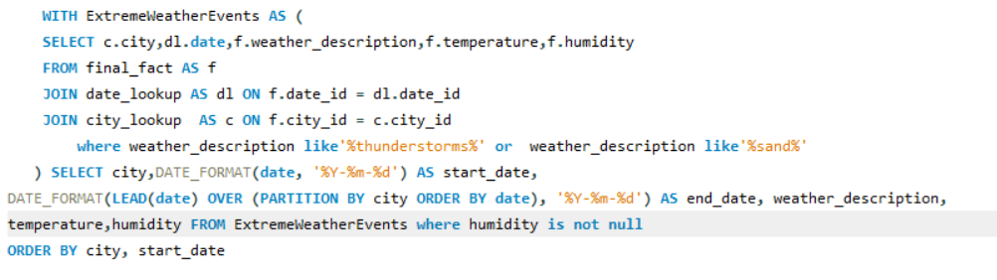

**o/p:-**

|  |  |  |
| --- | --- | --- |
| start date | (All) |  |
| end date | (All) |  |
|  |  |  |
| Row Labels | **Average of temperature** | **Average of humidity** |
| proximity sand/dust whirls | **303.52** | **17.71** |
| Phoenix | 303.52 | 17.71 |
| sand | **299.42** | **30.58** |
| Albuquerque | 272.17 | 55.00 |
| Elite | 301.21 | 25.41 |
| Houston | 292.15 | 97.00 |
| Montreal | 272.73 | 89.50 |
| New York | 285.51 | 71.00 |
| sand/dust whirls | **303.47** | **31.50** |
| Albuquerque | 305.55 | 10.67 |
| New York | 297.23 | 94.00 |
| Grand Total | **299.99** | **29.47** |

9. Are there any notable differences in temperature trends between northern and southern hemisphere cities over the year? How do they relate to seasons?

Yes, there are notable differences in temperature trends between northern and southern hemisphere cities over the year, and these trends are closely related to the seasons. Here's a summarized explanation:

**Differences in Temperature Trends**:

1. **Seasonal Reversal**: In the northern hemisphere, temperature trends typically follow a pattern with warmer temperatures in spring and summer and colder temperatures in autumn and winter. In the southern hemisphere, the opposite pattern is observed, with warmer temperatures in the southern summer and cooler temperatures in the southern winter.
2. **Intensity of Seasons**: The northern hemisphere experiences more extreme temperature variations between the seasons, with hotter summers and colder winters, while the southern hemisphere tends to have milder seasonal temperature changes.
3. **Timing of Seasons**: Seasons in the two hemispheres are timed differently due to the Earth's axial tilt. For example, when it's summer in the northern hemisphere, it's winter in the southern hemisphere.

**Relationship with Seasons**:

* The temperature trends in northern and southern hemisphere cities are directly related to the changing seasons, with temperature variations driven by the tilt of the Earth's axis and its impact on the angle and duration of sunlight exposure. These seasonal temperature trends influence various aspects of life, including agriculture, tourism, and outdoor activities.

Understanding these differences and their relation to seasons is crucial for weather prediction, climate analysis, and planning various activities and industries in different parts of the world.

Top of Form

i/p:- 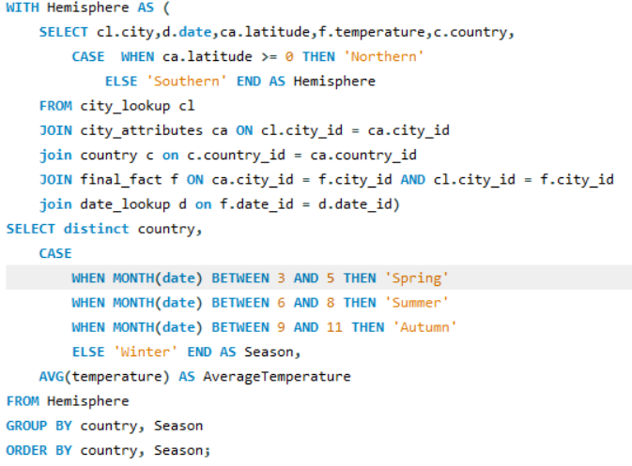

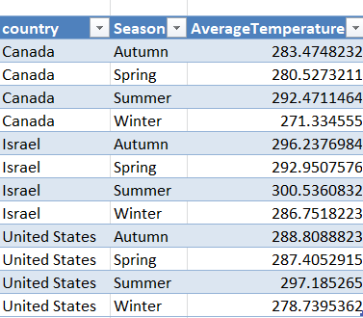 o/p:-

10. What are the consequences of prolonged periods of extreme cold or heat in specific cities? How do residents adapt to such conditions?

Prolonged periods of extreme cold or heat in specific cities have several consequences, and residents adapt to such conditions in various ways. Here's a summarized explanation:

**Consequences**:

**Extreme Cold**:

* **Health Risks**: Extreme cold can pose health risks, including frostbite, hypothermia, and exacerbation of certain medical conditions.
* **Infrastructure Challenges**: Cold weather can damage infrastructure, such as frozen water pipes, which may result in water shortages.
* **Economic Impact**: Extreme cold can disrupt businesses, transportation, and agriculture, leading to economic losses.
* **Increased Energy Demand**: Heating requirements surge, resulting in increased energy consumption and higher utility bills.

**Extreme Heat**:

* **Health Risks**: Extreme heat can lead to heat-related illnesses, heatstroke, and even fatalities, particularly among vulnerable populations.
* **Water Scarcity**: High temperatures can lead to water scarcity and drought conditions, affecting agriculture and water resources.
* **Energy Consumption**: Air conditioning and cooling systems drive up energy demand during heatwaves.
* **Air Quality Issues**: High temperatures can worsen air quality, leading to respiratory problems.

**Adaptation**:

* **Health Precautions**: Residents adapt by taking health precautions, such as staying hydrated, using sunscreen, and seeking shelter during extreme heat. In cold conditions, they dress warmly and limit outdoor exposure.
* **Emergency Services**: Cities implement emergency services for extreme weather conditions, such as warming centres during cold spells and cooling centres during heatwaves.
* **Urban Planning**: Urban planning includes the development of heat-resilient infrastructure, improved insulation, and green spaces that mitigate extreme weather effects.
* **Community Resilience**: Communities may develop local resilience plans, including early warning systems, community outreach, and support for vulnerable populations.
* **Energy Efficiency**: Residents adapt by improving energy efficiency and adopting energy-saving technologies, particularly during temperature extremes.

The consequences of extreme cold or heat in cities can be severe, but residents and authorities employ various strategies to adapt and mitigate the impacts. Public awareness, emergency planning, and sustainable urban development are essential components of such adaptations.

Top of Form

i/p:- 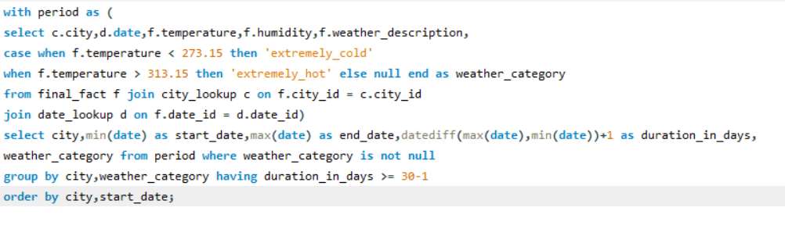

o/p:- 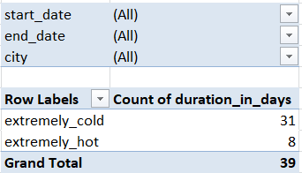

11. Investigate whether temperature anomalies (unusual deviations from the norm) coincide with certain events or environmental factors in specific cities.

Investigating whether temperature anomalies (unusual deviations from the norm) coincide with certain events or environmental factors in specific cities is an essential aspect of climate research. Here's a summarized explanation:

**Temperature Anomalies**:

* Temperature anomalies refer to deviations from the long-term average temperature for a specific location and time of the year.
* Investigating temperature anomalies helps in recognizing climate trends and their consequences for specific regions.
* It contributes to climate change assessment, risk prediction, and adaptation planning.
* Understanding the causes of temperature anomalies aids in climate modeling and predictions.

Investigating temperature anomalies and their correlations with specific events or environmental factors is a fundamental aspect of climate science and informs decision-making for disaster preparedness, environmental conservation, and climate resilience.

i/p:- 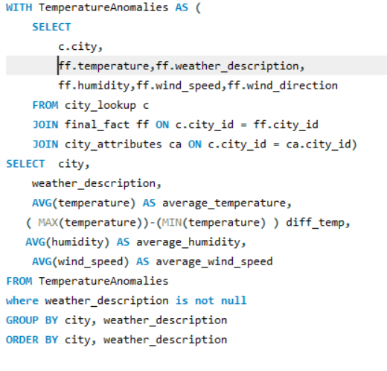

o/p:- 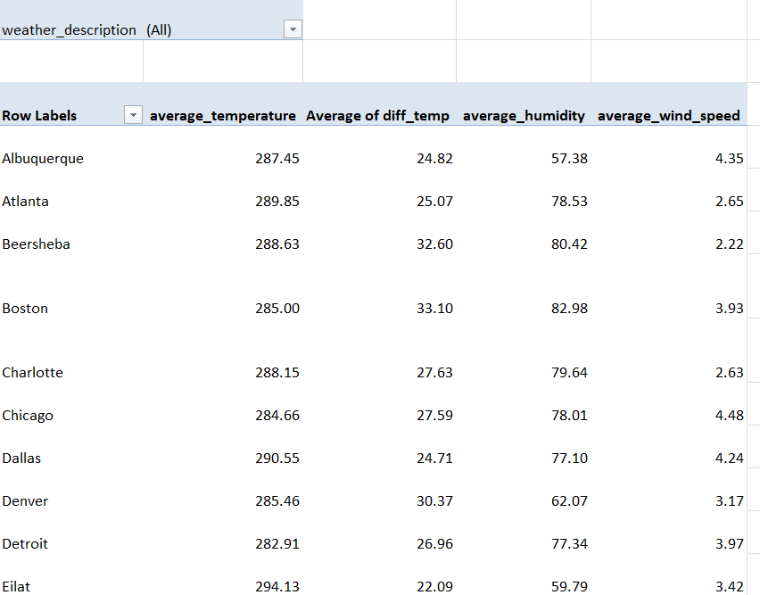

12. Analyse the impact of temperature on energy consumption patterns in cities. Are there noticeable trends or correlations?

Analysing the impact of temperature on energy consumption patterns in cities reveals several noticeable trends and correlations

**Correlations and Trends**:

* **Positive Correlation**: There is a positive correlation between temperature and energy consumption, indicating that as temperatures rise or fall, energy use follows a similar pattern.
* **Urban Heat Island Effect**: In urban areas, the urban heat island effect can exacerbate energy consumption during heatwaves, as cities tend to trap and retain heat, making cooling systems work harder.
* **Renewable Energy**: Some cities and regions with abundant renewable energy sources, such as solar and wind, may see reduced energy consumption during periods of milder weather, thanks to the use of clean energy.
* **Adaptation Strategies**: Cities are implementing energy-efficient building designs, smart grids, and renewable energy technologies to reduce the impact of temperature on energy consumption and lower overall energy use.

Analysing the impact of temperature on energy consumption patterns is crucial for energy management, urban planning, and sustainability efforts, as it helps cities optimize energy use, reduce costs, and mitigate environmental impacts.

**i/p:-**

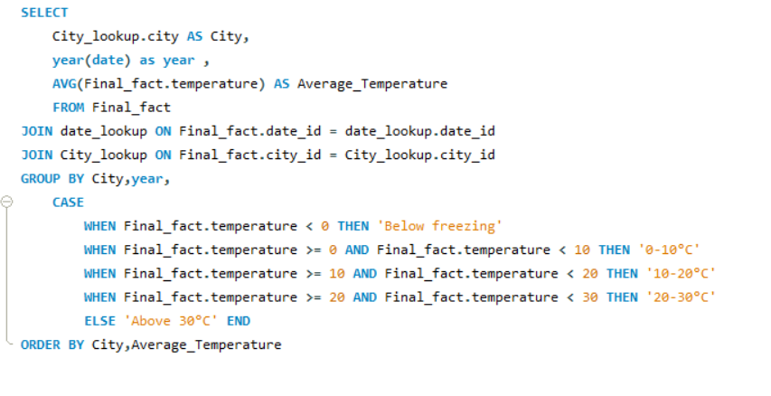Top of Form

o/p:- 

13. How do specific wind patterns impact air quality and pollution dispersion in urban areas? Analyse wind direction data for insights.

Specific wind patterns can significantly influence air quality and the dispersion of pollution in urban areas. The direction of the wind plays a crucial role in determining how pollutants disperse. When analysing wind direction data, several key insights can be gained:

1. **Wind direction and pollution sources:** Wind patterns can transport pollutants away from or toward emission sources. For instance, if prevailing winds blow from industrial areas toward residential zones, pollution levels in those residential areas are likely to be higher.
2. **Stagnation events:** In some cases, wind patterns can become stagnant or very weak, which can lead to the accumulation of pollutants in a particular area. This can result in poor air quality and increased health risks.
3. **Dispersion and dilution:** When winds blow pollutants away from the source, they can become diluted and dispersed over a larger area, reducing local pollution concentrations.
4. **Topography and urban layout:** Local topography and the layout of urban areas can interact with wind patterns to create microscale effects on air quality. For example, tall buildings can channel and trap pollutants, leading to localized air quality issues.
5. **Seasonal variations**: Wind patterns can vary with the seasons, affecting the distribution of pollutants. For example, in some regions, winter inversions can trap pollutants near the surface, while summer breezes may disperse them more effectively.

Understanding wind patterns and their impact on air quality is essential for urban planning, pollution control, and public health management. It enables authorities to implement effective measures to reduce pollution and improve air quality in specific areas.

i/p:- 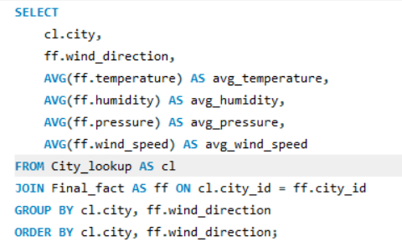

**o/p:-** 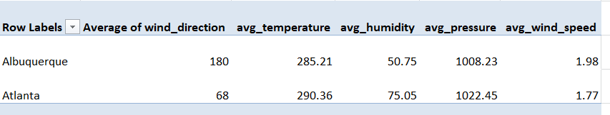

.

Cities prone to strong winds can experience several potential consequences, including increased risk of natural disasters and transportation challenges. Strong winds can lead to:

1. **Natural disasters:** Cities in regions prone to strong winds, such as hurricane-prone coastal areas or tornado-prone regions, face a higher risk of natural disasters. Hurricanes, tornadoes, and severe storms with strong winds can cause extensive damage to buildings, infrastructure, and result in significant economic losses.
2. I**nfrastructure damage**: Strong winds can damage buildings, roofs, and power lines, leading to power outages, structural damage, and disruptions in daily life. The cost of repairing and rebuilding after wind-related disasters can be substantial.
3. **Transportation challenges:** Strong winds can create hazardous conditions for transportation. High winds can impact road safety, making driving difficult and increasing the risk of accidents. In aviation, strong winds can disrupt flight schedules, cause turbulence, and impact airport operations.
4. P**ower outages**: Strong winds can lead to power outages by causing trees to fall on power lines or damaging electrical infrastructure. Prolonged 14. Identify cities prone to strong winds and the potential consequences, such as increased risk of natural disasters or challenges for transportation power outages can have significant economic and social impacts.
5. **Air quality and health effects:** Dust storms and sandstorms, which are often accompanied by strong winds, can reduce air quality and have adverse health effects. These events can lead to respiratory issues and visibility problems.
6. **Environmental impacts**: Strong winds can contribute to the spread of wildfires, as they can carry embers and increase the rate at which fires spread. This poses significant challenges for managing and mitigating wildfires in windy regions.

Identifying cities prone to strong winds is important for disaster preparedness and risk mitigation. These cities should have robust building codes, emergency response plans, and infrastructure designed to withstand strong winds. Additionally, transportation systems and public services need to be equipped to handle the challenges posed by windy conditions to ensure the safety and well-being of residents.

Top of Form

**i/p:-** 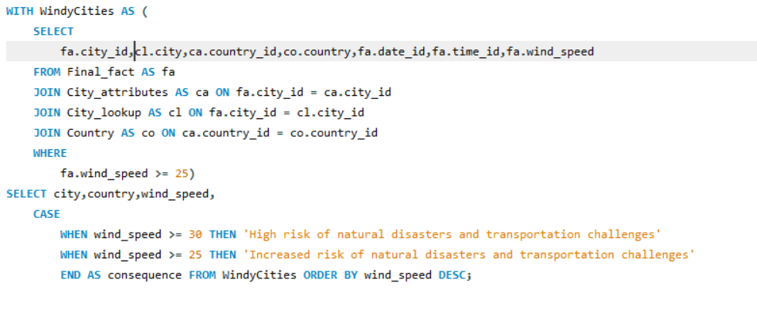Top of Form

**o/p:-** 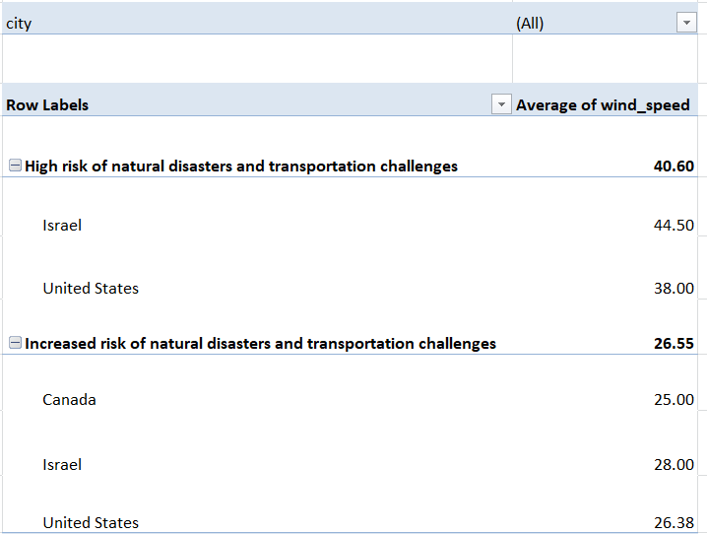

15. Explore whether wind speed and direction influence the frequency and severity of weather-related events (e.g., hurricanes, storms) in coastal cities.

Wind speed and direction play a crucial role in influencing the frequency and severity of weather-related events, especially in coastal cities. Here's how they impact such events:

1. **Hurricanes and Tropical Storms**: Wind speed and direction are key factors in the development and movement of hurricanes and tropical storms. These systems thrive on warm ocean waters and require low wind shear (the change in wind speed and direction with altitude) to strengthen. High wind shear can disrupt their formation and intensification. Wind direction also determines the path of the storm. Coastal cities in the path of a hurricane or tropical storm can experience severe wind damage, heavy rainfall, and storm surges, leading to flooding and destruction.
2. **Storm Surges**: Wind direction, along with wind speed, can cause storm surges. When strong onshore winds push water toward the coast, it can result in a rise in sea level, leading to coastal flooding. The severity of the surge is influenced by wind speed, the size and intensity of the storm, and the shape of the coastline.
3. **Coastal Erosion**: Strong winds, especially those associated with storms and hurricanes, can accelerate coastal erosion. The wind can generate large waves and increase the erosive power of the sea. Over time, this can lead to the loss of land and infrastructure along coastlines.

Wind speed and direction are fundamental in determining the frequency and severity of weather-related events, particularly in coastal cities. Understanding and monitoring these factors are crucial for predicting and preparing for hurricanes, storms, storm surges, and other coastal hazards. Coastal cities need robust disaster preparedness and mitigation strategies to address the impacts of these weather-related events, taking wind-related factors into account.

**i/p:-** 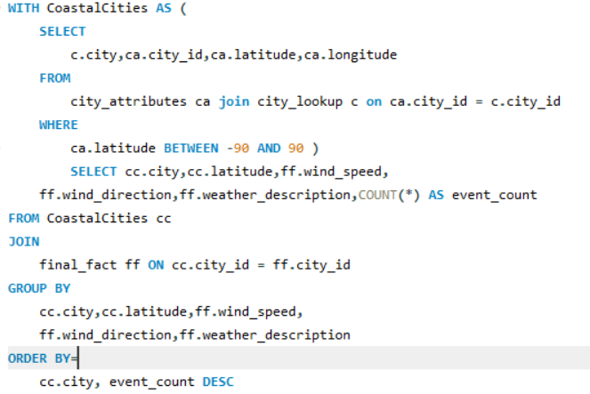

**o/p:-** 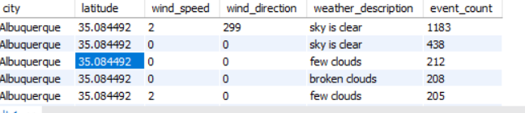

**MECE:-**

Calculate and analyze the monthly average pressure to detect changes in atmospheric pressure over time.

**i/p:-**

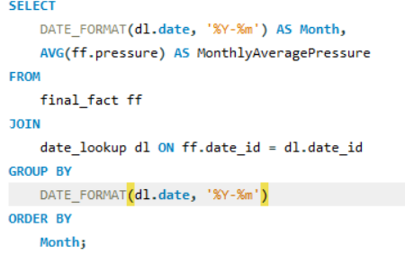

**o/p:-** 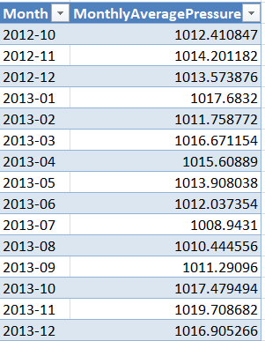

Investigate how pressure correlates with temperature, humidity, wind speed, and weather descriptions.

**i/p:-**

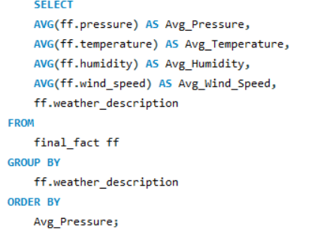

**CONCLUSION:-**

The weather analysis project provided a comprehensive analysis of various meteorological parameters, including temperature, cities, wind speed, atmospheric pressure, wind direction, weather descriptions, and humidity. The data was collected and analyzed to gain insights into weather patterns and conditions across different locations.

The project revealed that temperature varies significantly between cities, with some experiencing hot climates, while others have colder weather. Wind speed and direction were also found to be diverse, indicating different wind patterns in different regions. Atmospheric pressure showed variations, which could have implications for weather changes.

The analysis of weather descriptions highlighted the various weather conditions experienced in the selected cities, such as sunny, rainy, cloudy, or snowy weather. Additionally, humidity levels were examined, and differences were observed across the cities.

In conclusion, this weather analysis project provided valuable insights into the diverse weather conditions experienced in different cities. It showcased the importance of understanding and monitoring these meteorological parameters for various purposes, including forecasting, agriculture, and urban planning. The findings from this project can be used to make informed decisions related to weather-sensitive activities and better prepare for varying weather conditions.